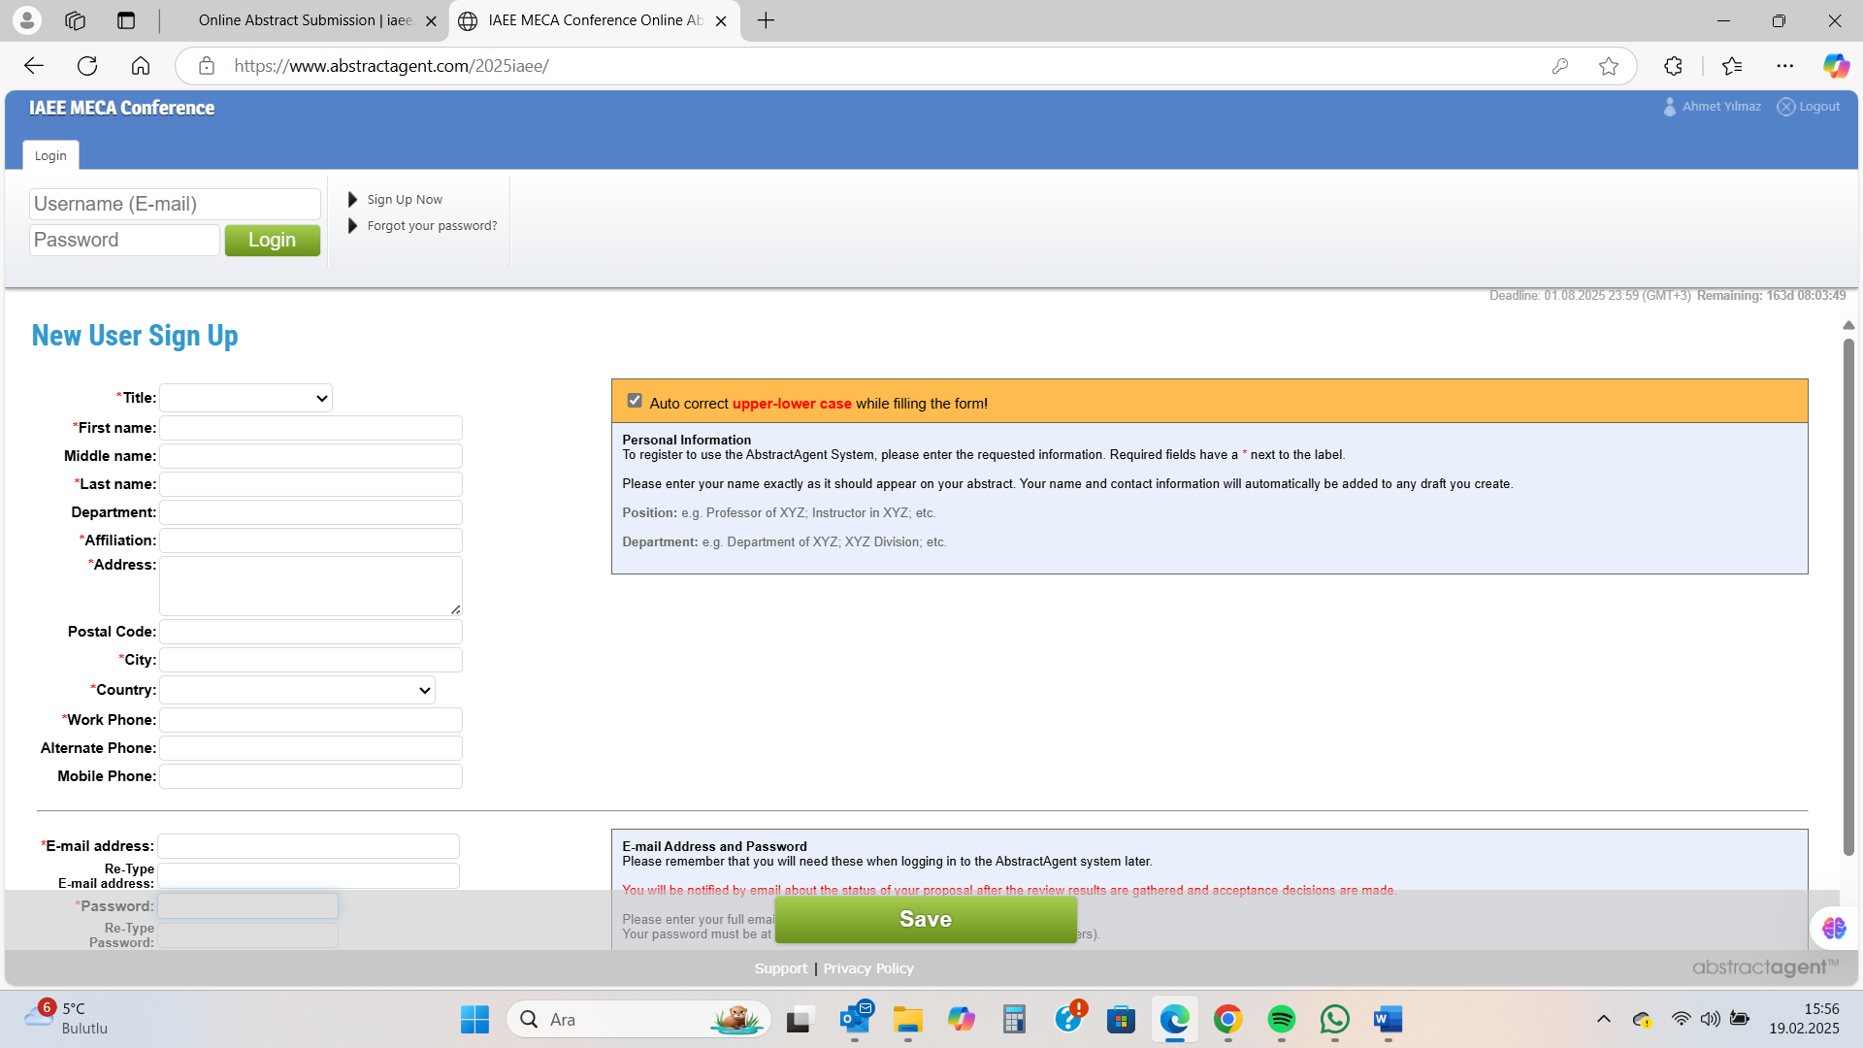
To begin, you must “sign up now” for the system by entering personal information about yourself. Throughout the entire process, carefully read the provided instructions and fill out the form accordingly. Enter your email address and password into the section located at the end of the page. Save it.
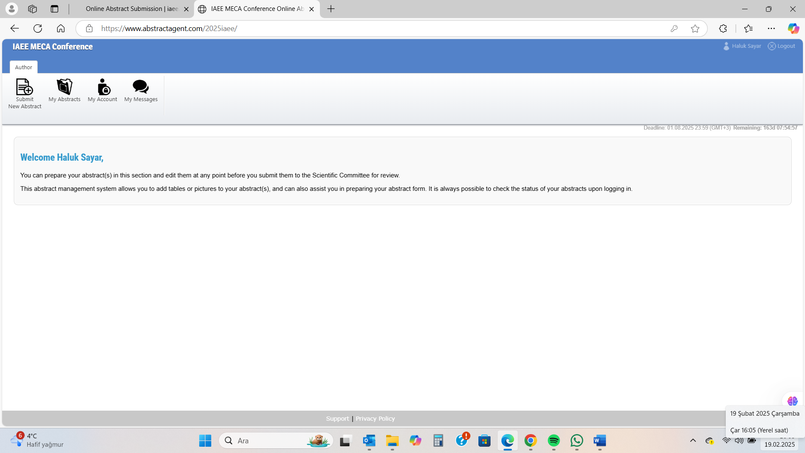

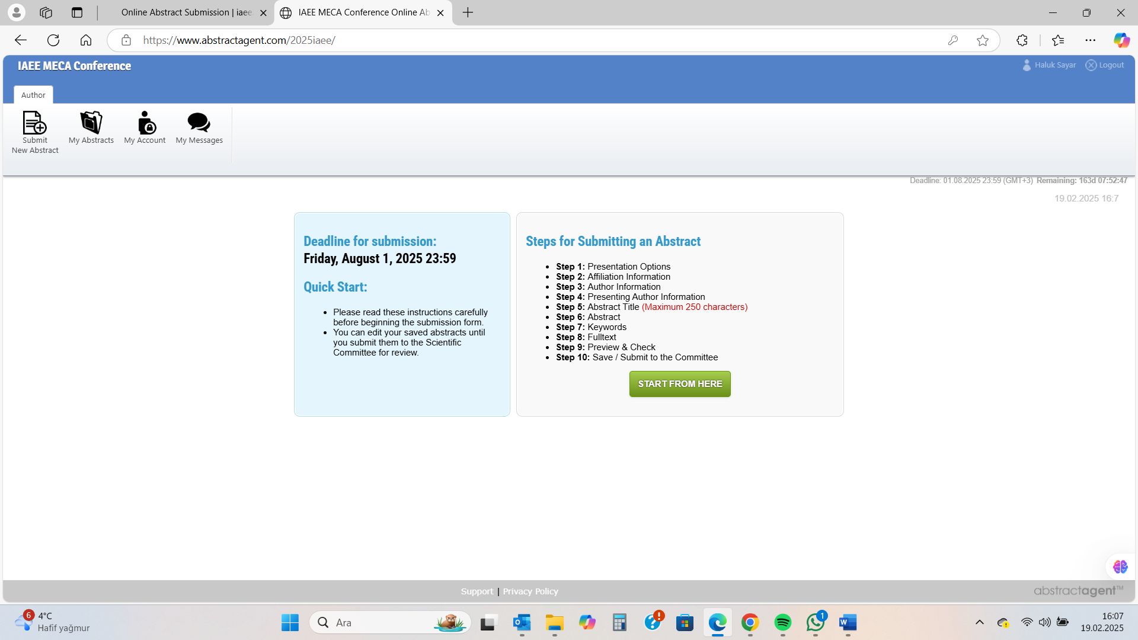
You can start uploading your abstract in the 10-step process by pressing the "Start from here" button.
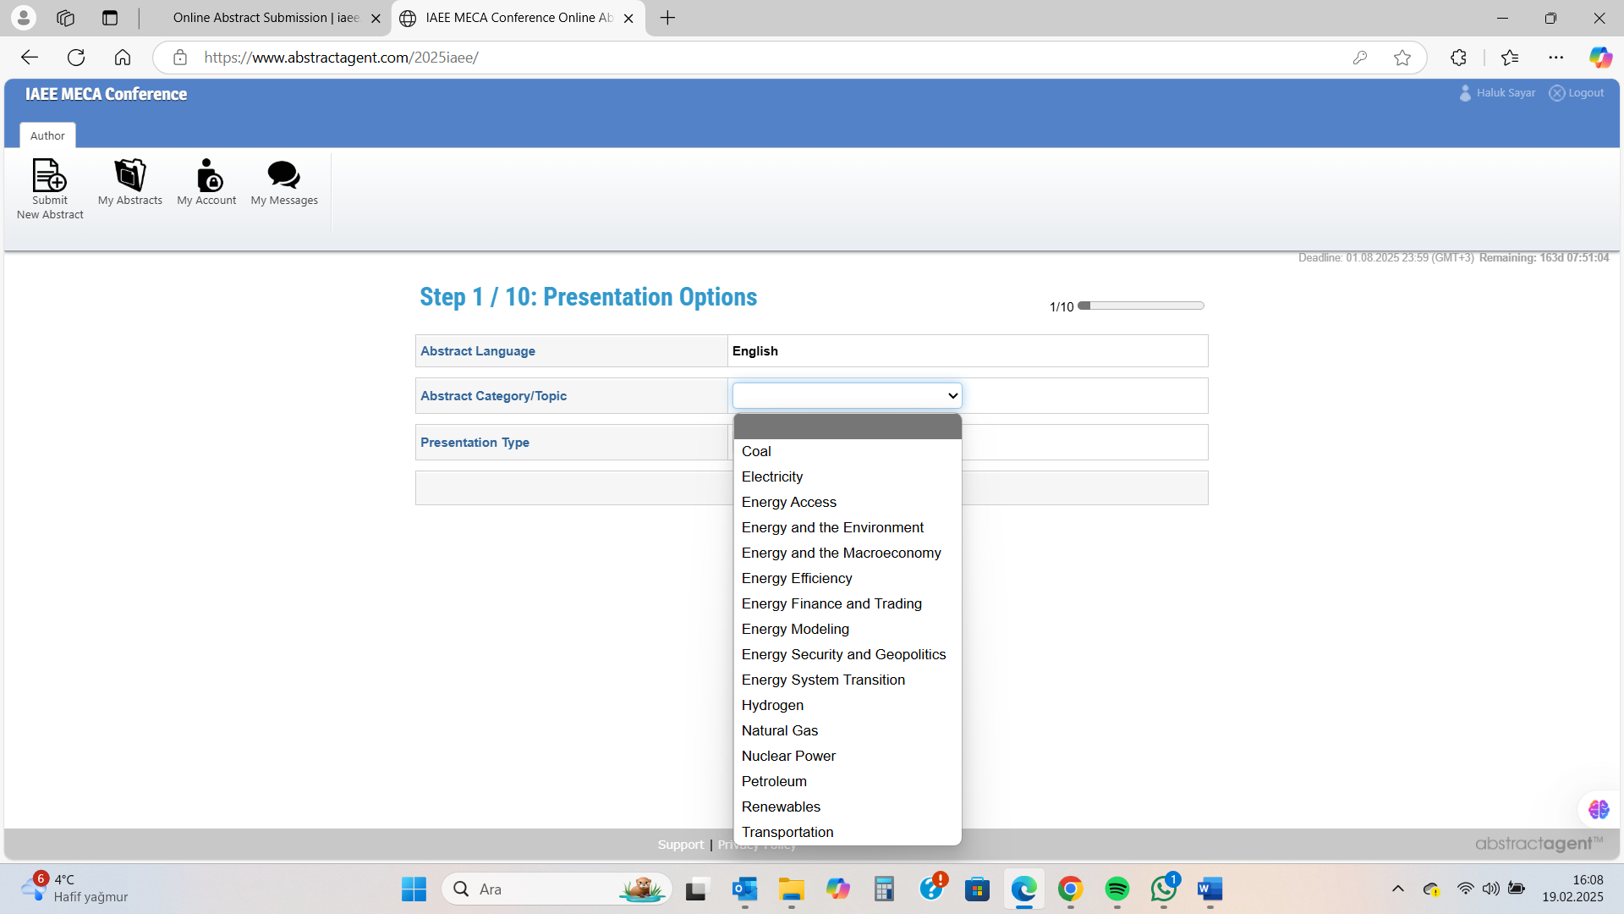
Select the main category under which your abstract falls from the provided headings.
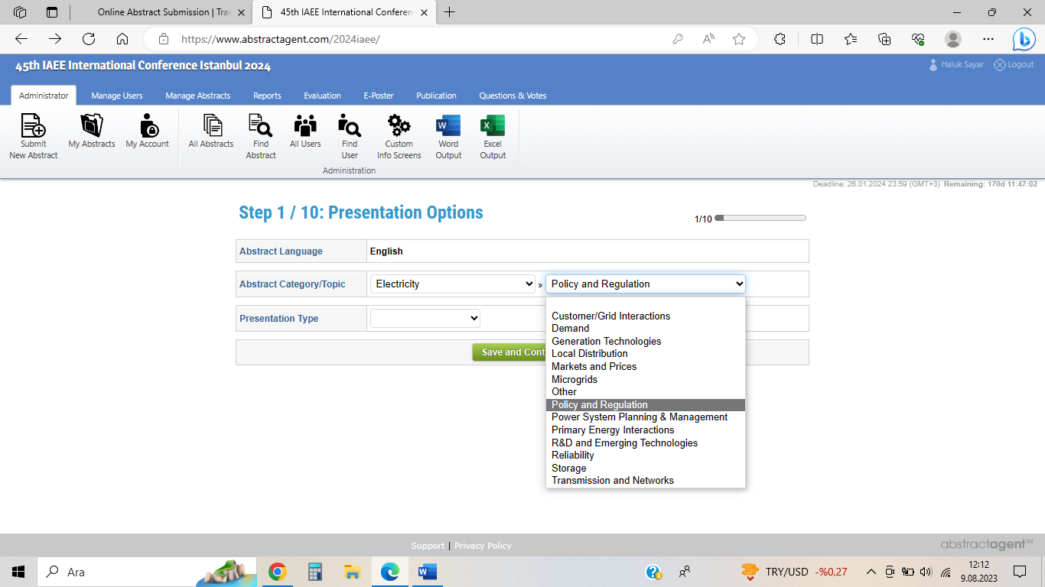 Then, under the main heading, choose the most suitable sub-category for your abstract from the specified sub-categories.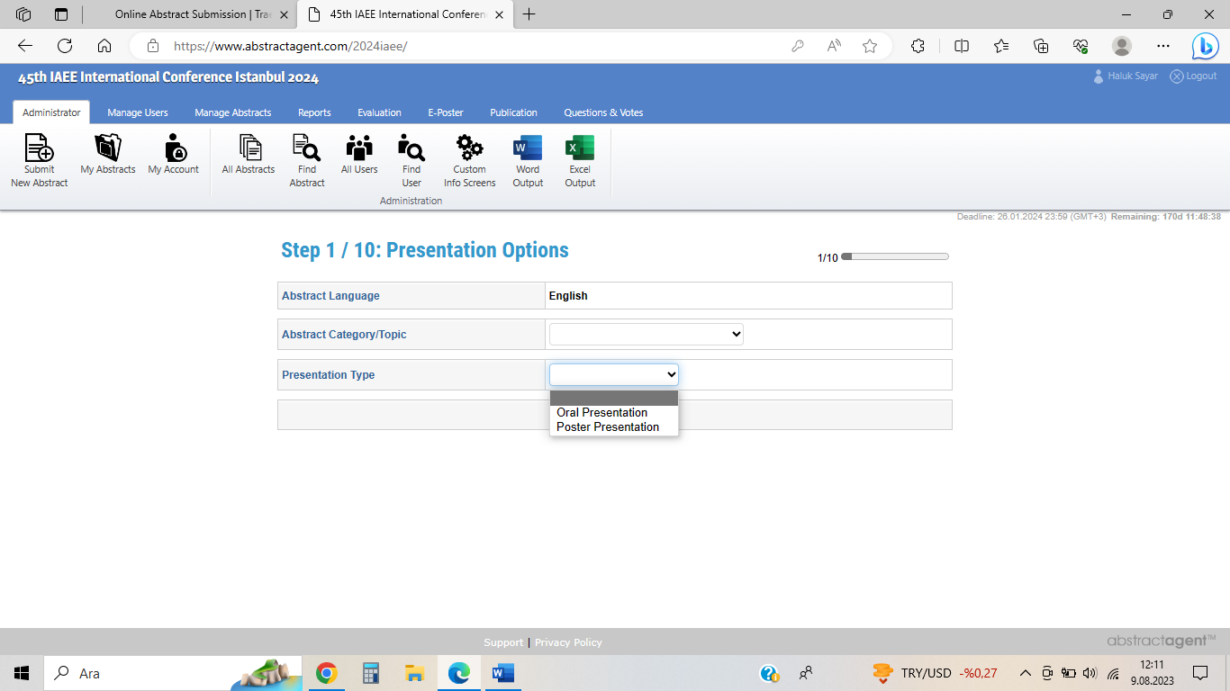Choose your presentation type and Save the page.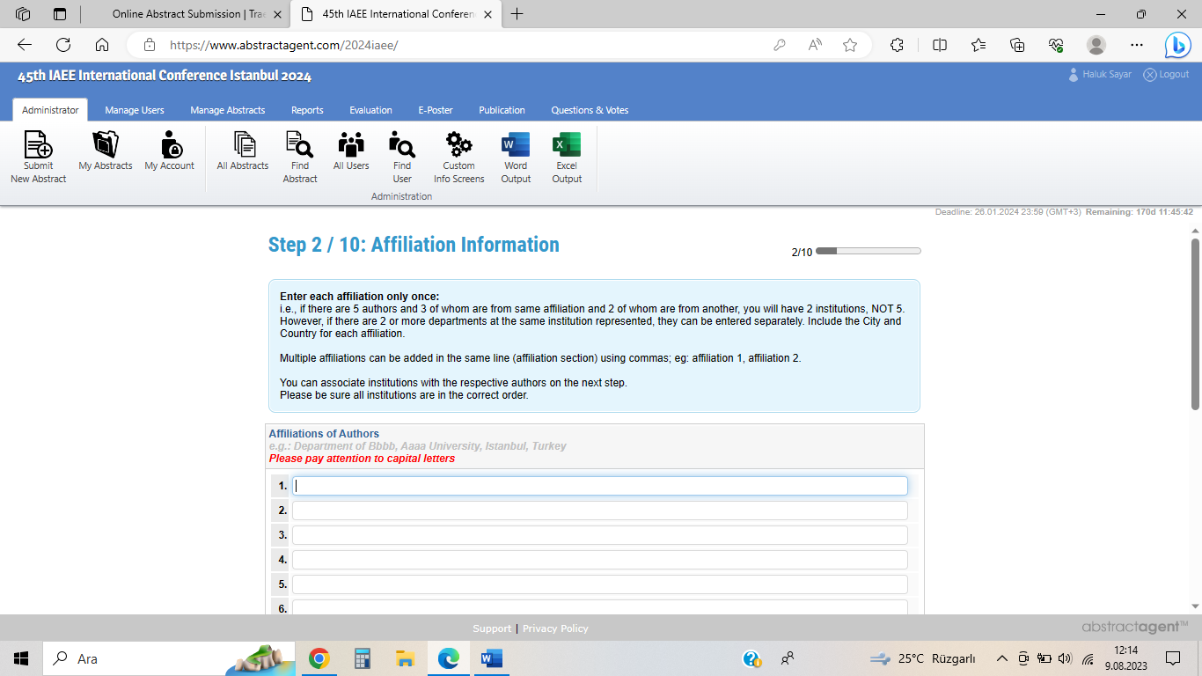
Specify the affiliate names according to the instructions provided on the pageand save it.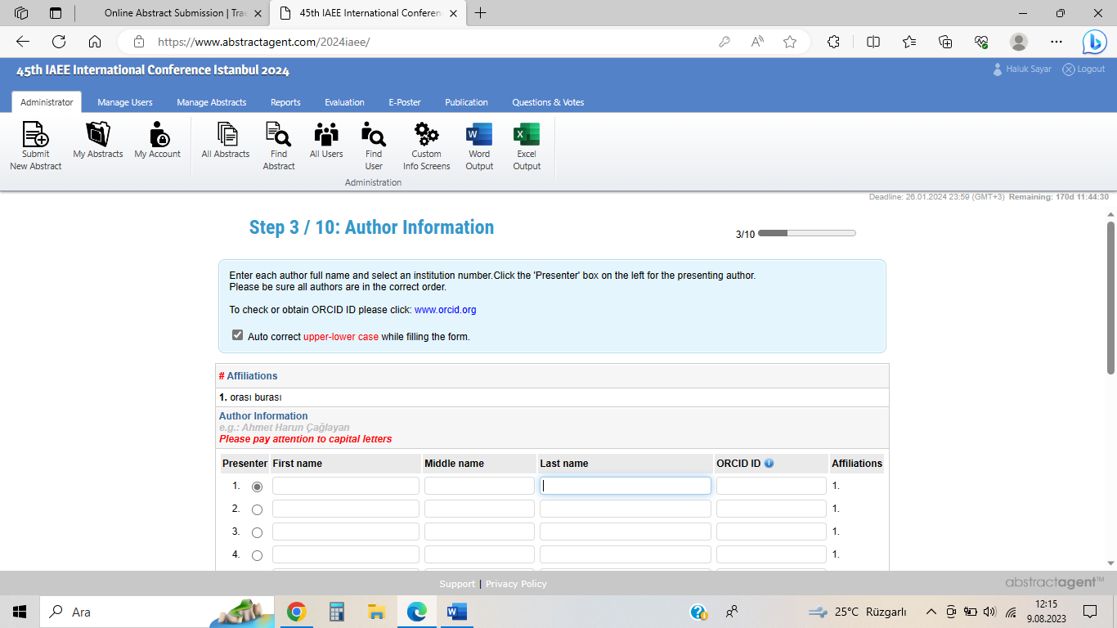
And enter the authors information and save it.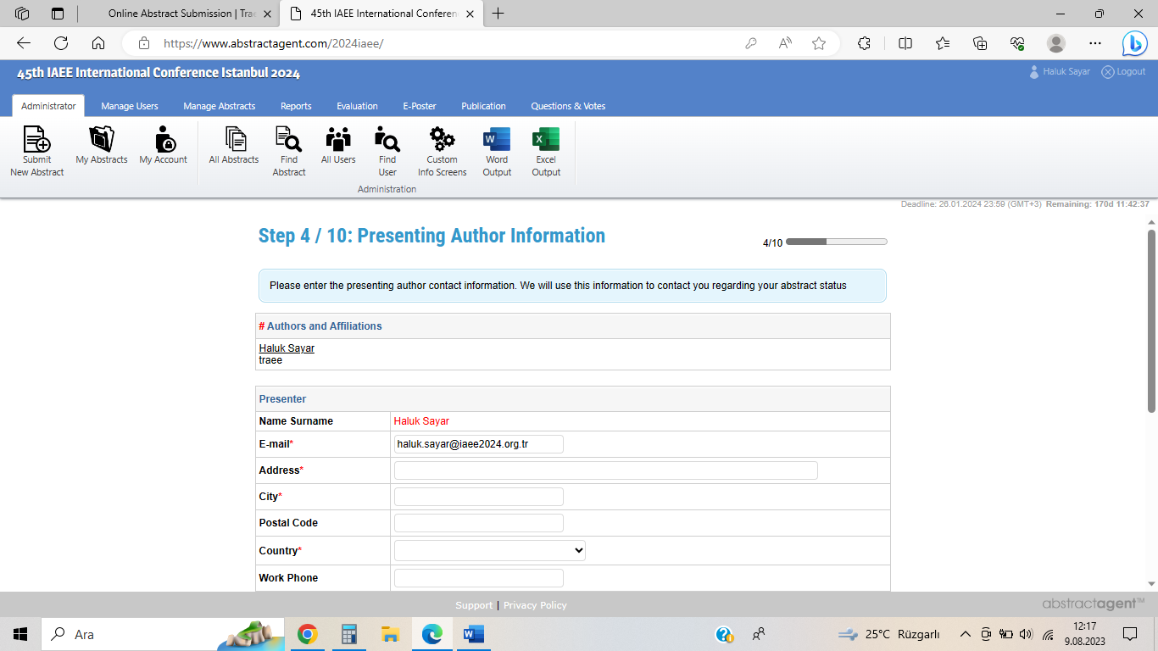
Fill in the complete information about the person who will present the presentation and save it.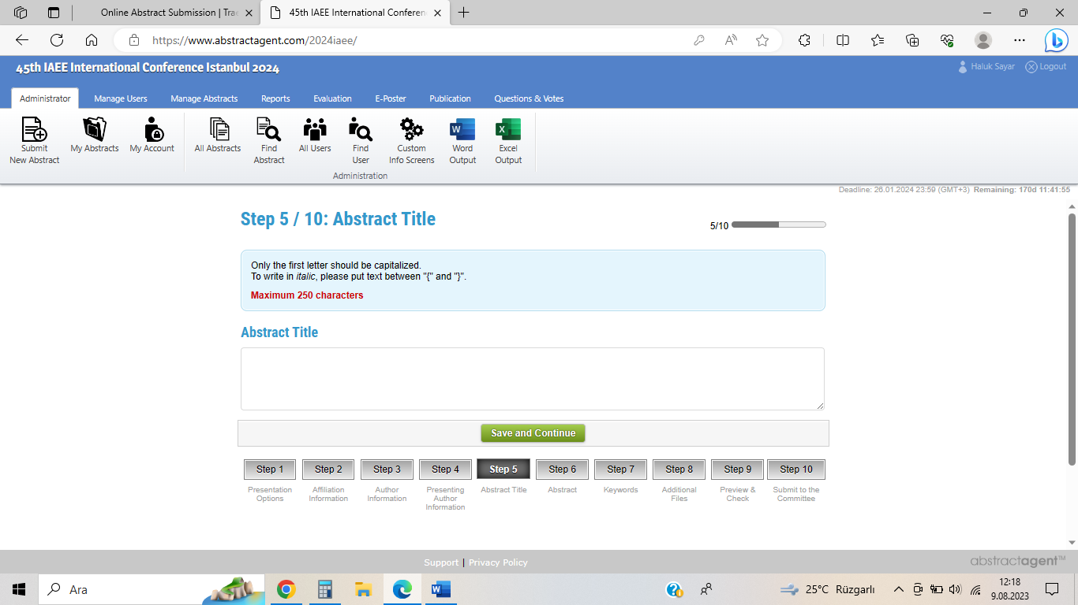
Enter your abstract title into this section and save it.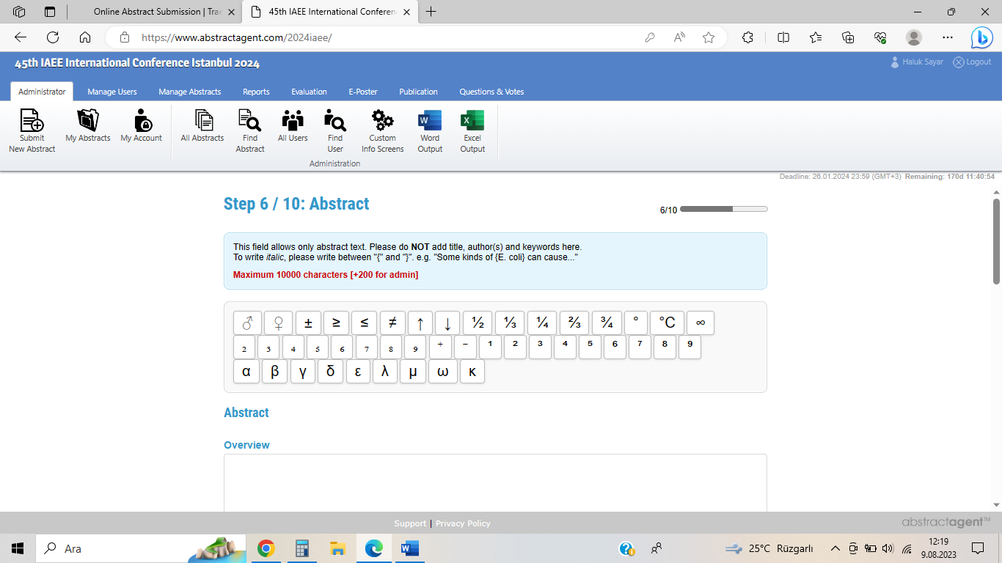 You can now start uploading your abstract. Following the IAEE methodology, copy your abstract under the sections of Overview, Methods, Results, Conclusions, and References. Save the page.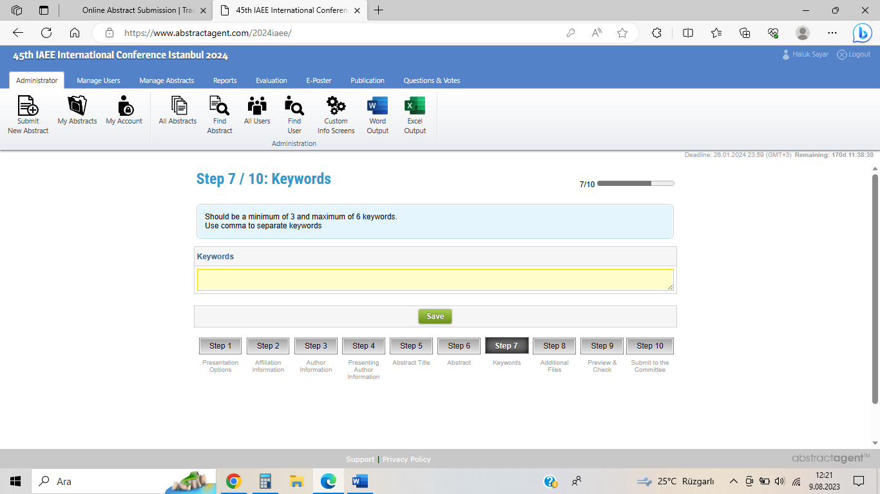
Specify keywords in 3 to 6 words.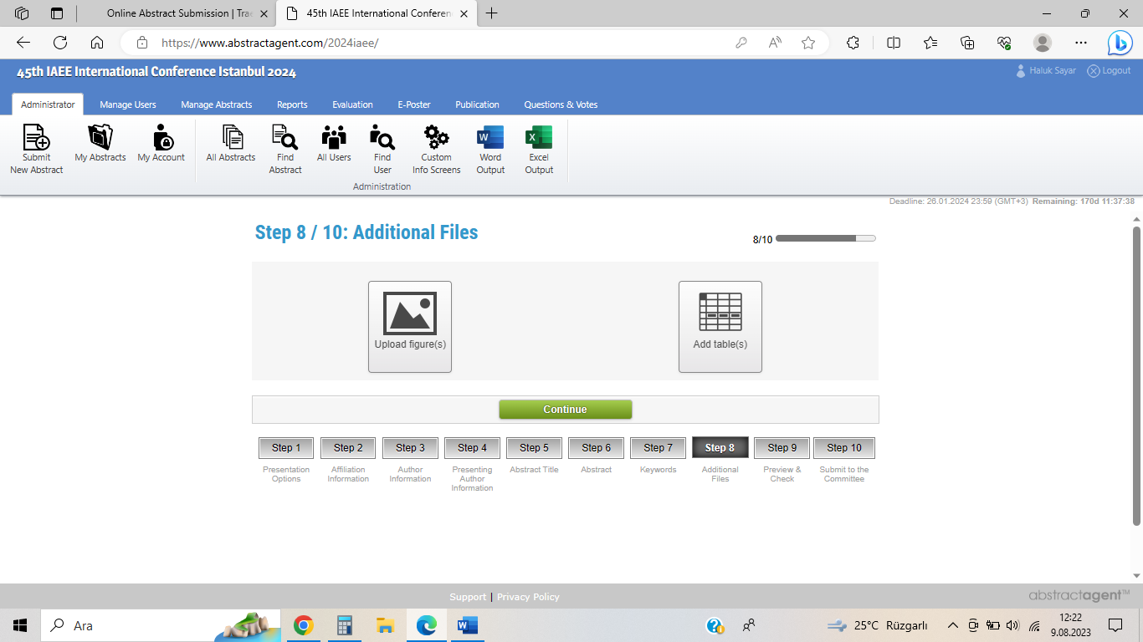 https://chat.openai.com/#:~:text=Upload%20supporting%20documents%20such%20as%20images%2C%20graphics%2C%20tables%2C%20etc.%20found%20in%20your%20abstract.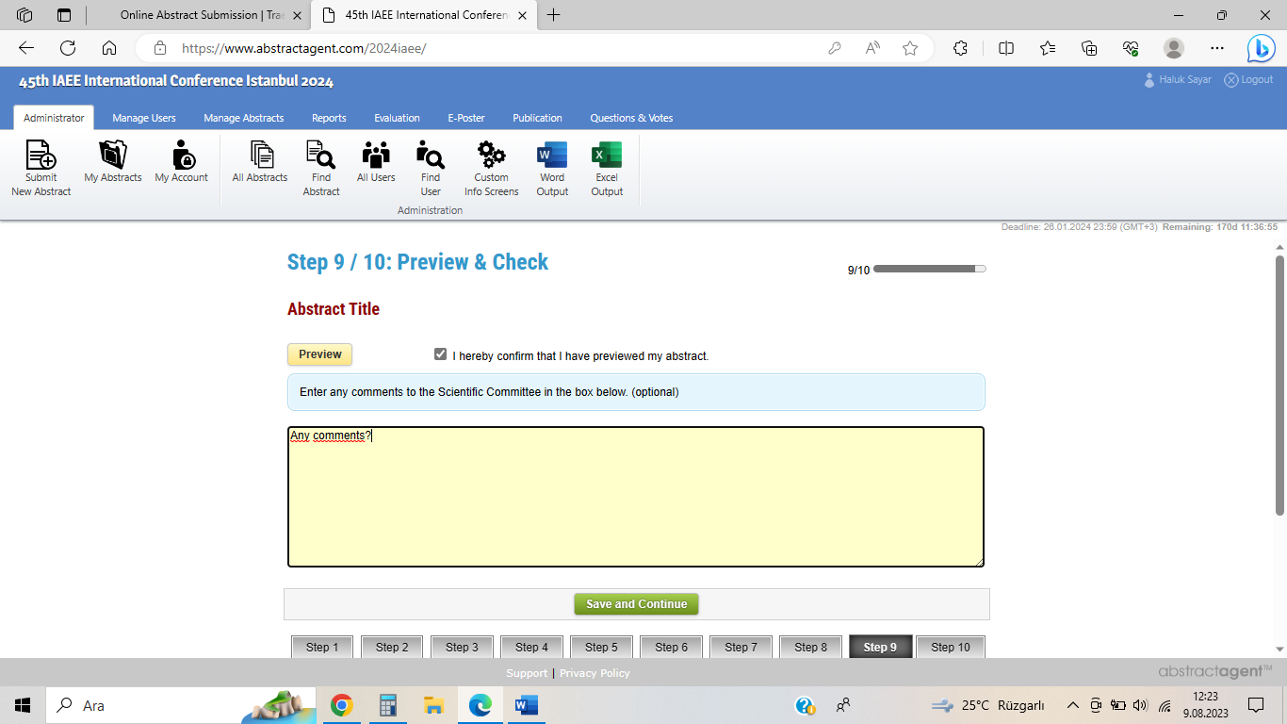 On this page, you will be able to preview your submission. Please review your abstract. If you believe there is an error, proceed to the necessary step to revise your abstract. Check the box confirming that you've seen the preview. If you have any comments, write them for the program committee's consideration.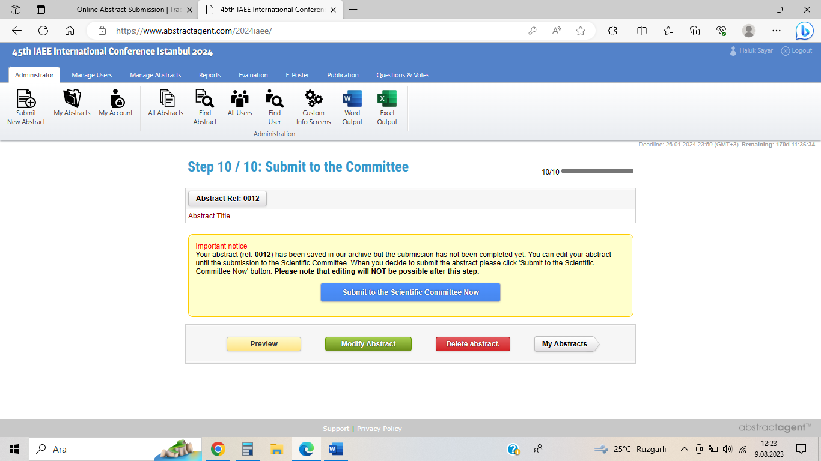 With this final step, you can submit, delete, modify, or preview your abstract.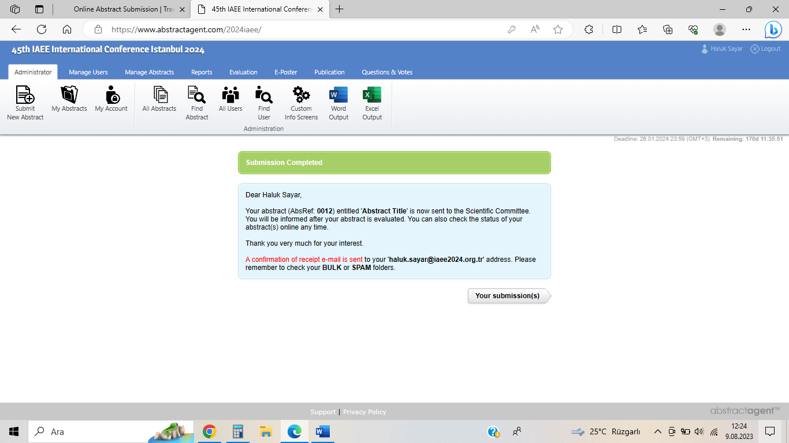 After submitting the abstract, you will see a page as shown above. 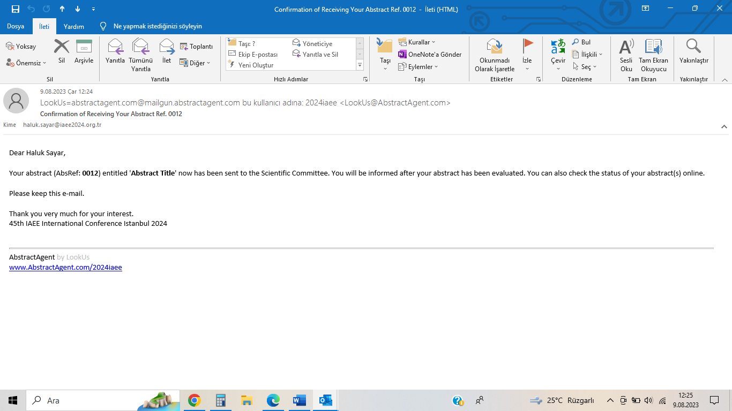 Then, check your provided email to ensure you receive an automated email sent by us as depicted above. That's all, best of luck...

